**ASSESSMENT - 2**

1 ans.

The logistic function in logistic regression maps the linear combination of features and weights to a probability between 0 and 1. It is defined as:

σ(z)= 1/1+e^-z

where z is the linear combination of features and weights. This function helps compute the probability that a given input belongs to a particular class. By applying the logistic function, we get the output into a range suitable for probabilistic interpretation.

2 ans.

When constructing a decision tree, one commonly used criterion to split nodes is called the "information gain," particularly for classification tasks. The information gain measures the effectiveness of a particular attribute in classifying the training data. The attribute with the highest information gain is chosen as the splitting criterion for a node.

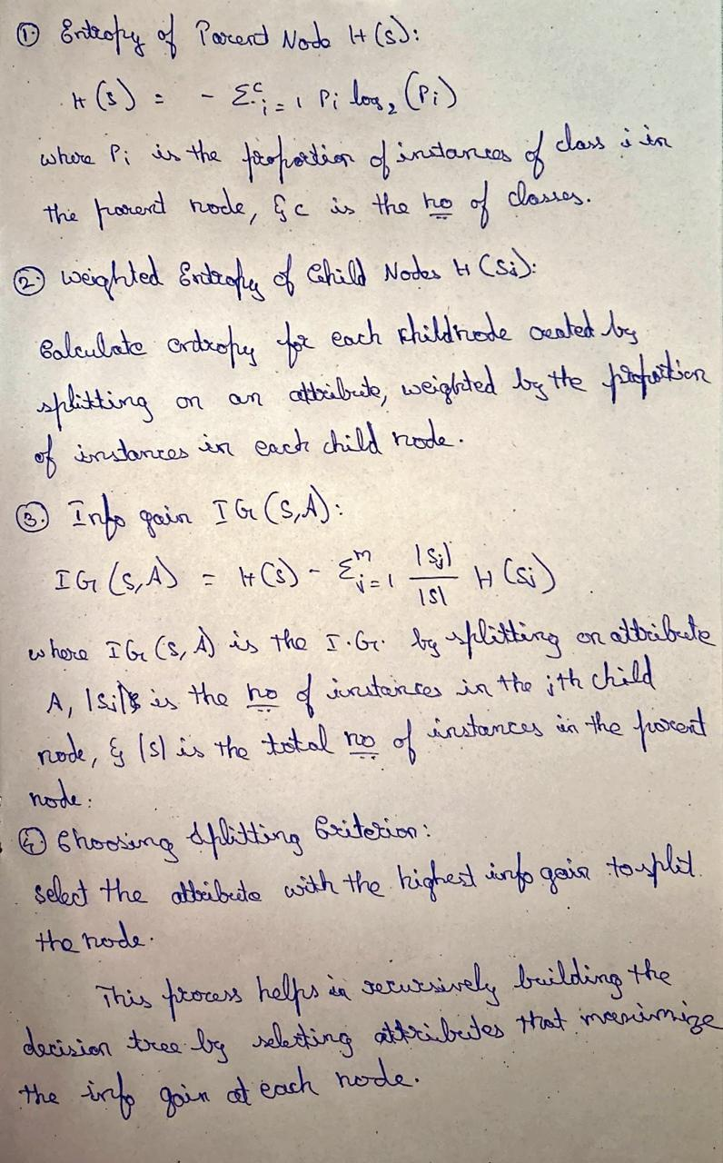

3 ans.

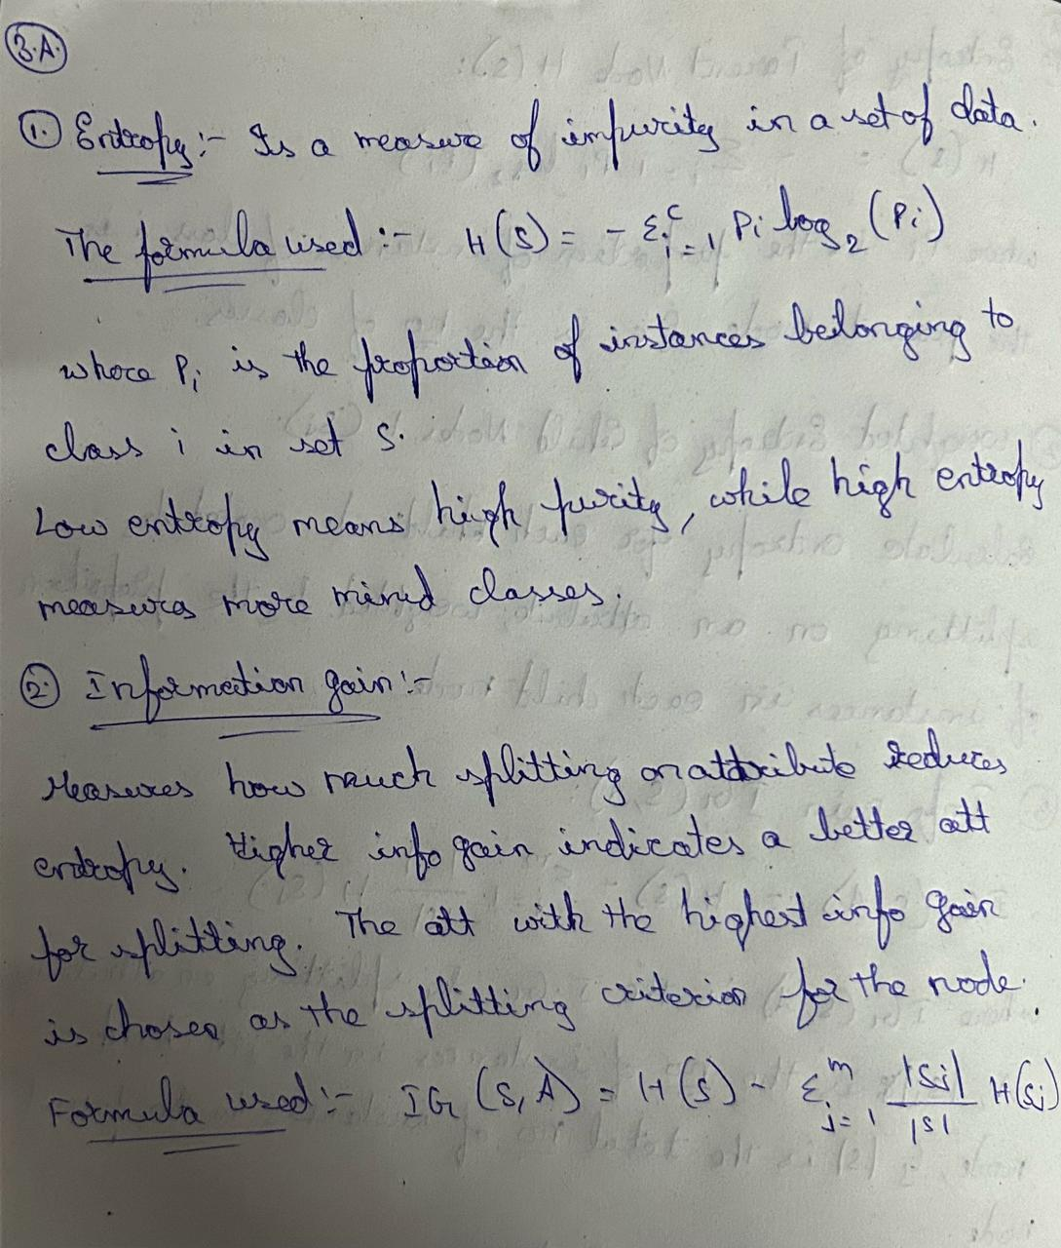

4 ans.

Bagging (Bootstrap Aggregating):

It creates many different small groups of data by randomly picking samples with replacement.

Each group is used to train its own decision tree.

By combining the predictions of all these trees, random forest gets better at making accurate predictions without overfitting.

Feature Randomization:

When building each tree, only a random subset of features is considered at each split.

This prevents the trees from all looking the same and helps them focus on different parts of the data.

By using different subsets of features, random forest becomes more flexible and accurate.

5 ans.

Euclidean Distance:

Euclidean distance calculates the straight-line distance between two points in Euclidean space.

It works well when the features are continuous and have similar scales.

However, it may not perform optimally when the data has categorical or ordinal features or when the feature scales vary greatly.

Manhattan Distance:

Manhattan distance calculates the distance as the sum of the absolute differences between coordinates.

It is more suitable for high-dimensional data or data with features that are not continuous.

Manhattan distance can perform better than Euclidean distance in situations where the features are not uniformly scaled or when outliers are present.

Minkowski Distance:

Minkowski distance is a generalized form that includes both Euclidean and Manhattan distances as special cases.

It has a parameter p that can be adjusted to control the sensitivity to different features. By adjusting the value of p, Minkowski distance can adapt to different types of data and feature distributions.

The choice impacts KNN's performance based on the data's characteristics and the problem requirements.

6 ans.

The Naïve Bayes algorithm assumes that the features used in classification are conditionally independent given the class label. In other words, it assumes that the presence or absence of a particular feature is unrelated to the presence or absence of any other feature, given the class label. This assumption simplifies the probability calculations involved in classification.

Implications for classification:

Simplicity:

The assumption of feature independence simplifies the computation of conditional probabilities, making the algorithm computationally efficient and easy to implement.

Reduced Data Requirements:

Naïve Bayes can perform well even with small training datasets since it estimates parameters independently for each feature.

Potential for Inaccuracies:

In reality, features may not be completely independent, and violating this assumption can lead to inaccurate probability estimates.

Despite this, Naïve Bayes often performs well in practice, especially in text classification and spam filtering tasks where the assumption holds reasonably well.

Feature Selection:

Since Naïve Bayes assumes independence, the presence of irrelevant or redundant features may not significantly impact classification performance. However, feature selection techniques can still help improve accuracy and efficiency.

Overall, while the assumption of feature independence simplifies the Naïve Bayes algorithm, practitioners should be aware of its implications and consider the nature of the data when applying the algorithm.

7 ans.

In Support Vector Machines (SVMs), the kernel function is used to transform the input data into a higher-dimensional space where it may be more easily separable. The primary role of the kernel function is to compute the dot product between two feature vectors in this higher-dimensional space without explicitly computing the transformation itself. This allows SVMs to efficiently handle nonlinear decision boundaries. Commonly used kernel functions in SVMs include:

Linear Kernel:

It represents the simplest kernel function, suitable for linearly separable data. Polynomial Kernel:

It maps the data into a higher-dimensional space using a polynomial function, controlled by parameters

Radial Basis Function (RBF) Kernel (Gaussian Kernel):

It maps the data into an infinite-dimensional space using a Gaussian function, controlled by the parameter γ. The RBF kernel is widely used due to its flexibility in capturing complex decision boundaries.

Sigmoid Kernel:

It maps the data into a higher-dimensional space using a hyperbolic tangent function, controlled by parameters γ and r. The choice of kernel function and its parameters greatly influence the SVM's ability to model complex relationships in the data. Experimentation and cross-validation are typically employed to select the most suitable kernel function and optimize its parameters for a given dataset and task.

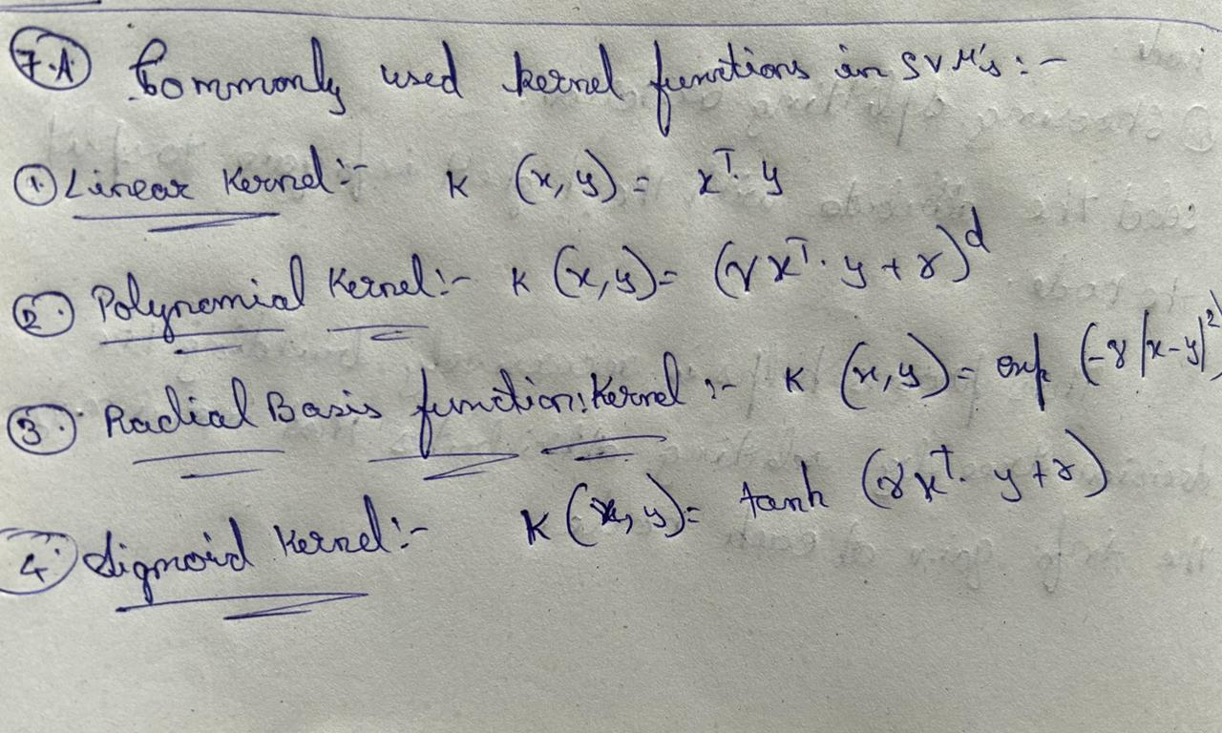

8 ans.

The bias-variance tradeoff is a fundamental concept in machine learning that addresses the balance between bias and variance as model complexity increases. It is closely related to the phenomenon of overfitting, where a model learns to capture noise in the training data rather than the underlying patterns, leading to poor generalization performance on unseen data.

Bias:

Measures error due to simplifying assumptions. High bias models are too simple to capture underlying patterns.

Variance: Measures sensitivity to training data fluctuations. High variance models capture noise instead of underlying patterns.

Model Complexity: Refers to a model's flexibility. Increasing complexity reduces bias but increases variance.

Tradeoff: There's an optimal level of complexity minimizing total error. Balancing bias and variance is crucial for good generalization.

Overfitting: Occurs when models capture noise instead of patterns. High complexity can lead to overfitting due to high variance.

Avoiding Overfitting: Regularization techniques can help control model complexity. Cross-validation and model selection aid in finding the right complexity level.

Therefore, the bias-variance tradeoff highlights the delicate balance between model complexity, bias, and variance. Understanding this tradeoff is essential for designing models that generalize well to unseen data and avoiding overfitting.

9 ans.

Easy-to-Use Tools: TensorFlow offers tools like Keras that make it simple to create and train neural networks. With these tools, you can focus on designing your neural network without worrying too much about technical details.

Computational Graphs: TensorFlow uses graphs to organize the calculations involved in training a neural network. This helps speed up the process and makes it easier to work with large amounts of data.

Gradient Computation: TensorFlow can automatically calculate gradients, which are used to update the neural network's parameters during training. This is a key part of how neural networks learn from data.

Optimization Algorithms: TensorFlow provides different algorithms to adjust the neural network's parameters during training, making it better at recognizing patterns in data.

Support for Different Network Types: Whether you're working with images, text, or sequences of data, TensorFlow has tools to help you build and train the right kind of neural network for your task.

Speed-Up with GPUs and TPUs: TensorFlow can make use of powerful hardware like GPUs and TPUs to train neural networks much faster than using just a regular CPU.

Visualization with TensorBoard: TensorFlow includes a tool called TensorBoard that helps you see how your neural network is doing during training. It shows you things like how the model's performance is improving over time and how the different parts of the network are working together.

10 ans.

Cross-validation is a technique used to assess how well a predictive model generalizes to an independent dataset. It involves partitioning the available data into multiple subsets, known as folds. The model is then trained on a subset of the data (training set) and evaluated on the remaining data (validation set). This process is repeated multiple times, with different partitions of the data used for training and validation in each iteration.

Importance of cross-validation in evaluating model performance:

Generalization Assessment: Cross-validation provides a more reliable estimate of a model's performance on unseen data compared to simply splitting the data into training and test sets. It helps assess how well the model generalizes to new, unseen instances.

Reduced Bias: By averaging the performance across multiple folds, cross-validation reduces the bias introduced by a single train-test split. It provides a more stable estimate of model performance.

Model Selection: Cross-validation helps in comparing different models or tuning hyperparameters. By evaluating each model on multiple folds of the data, it allows for a fair comparison of their performance and helps identify the best-performing model.

Data Utilization: Cross-validation makes efficient use of available data. Instead of using a fixed test set, which might be small and unrepresentative, it allows for the entire dataset to be used for both training and evaluation, albeit in different iterations.

Robustness to Data Variability: Cross-validation provides insights into how stable a model's performance is across different subsets of the data. A model that performs consistently well across multiple folds is likely to be more robust to variations in the dataset.

In summary, cross-validation is a crucial technique for evaluating model performance, selecting the best model, and tuning hyperparameters. It provides a more reliable estimate of a model's ability to generalize to new data and helps ensure that the model performs well across different subsets of the dataset.

11 ans.

Several techniques can be employed to handle overfitting in machine learning models:

Cross-Validation: Use techniques like k-fold cross-validation to assess the model's performance on multiple subsets of the data. This helps in evaluating how well the model generalizes to unseen data and reduces the risk of overfitting.

Train-Validation Split: Split the dataset into separate training and validation sets. Train the model on the training set and evaluate its performance on the validation set. This helps in monitoring the model's performance during training and detecting overfitting early.

Regularization: Regularization techniques like L1 (Lasso) and L2 (Ridge) regularization penalize large coefficients in the model, discouraging complex models that are prone to overfitting.

Cross-Validation for Hyperparameter Tuning: Use cross-validation to tune hyperparameters such as the regularization parameter. This helps in selecting the optimal hyperparameters that minimize overfitting.

Early Stopping: Monitor the model's performance on a validation set during training and stop training when the performance starts to degrade. This prevents the model from overfitting to the training data.

Feature Selection: Select only the most relevant features for training the model, discarding irrelevant or redundant features that could lead to overfitting.

Ensemble Methods: Ensemble methods like bagging, boosting, and random forests combine multiple models to reduce overfitting. By averaging or combining the predictions of multiple models, ensemble methods often generalize better than individual models.

Data Augmentation: Increase the size of the training dataset by applying transformations such as rotation, translation, scaling, or flipping to the existing data. This helps in exposing the model to more diverse examples and reduces overfitting.

Dropout: Dropout is a regularization technique commonly used in neural networks. It randomly drops a proportion of neurons during training, forcing the network to learn more robust features and reducing the reliance on any single neuron.

Simpler Model Architectures: Choose simpler model architectures that are less likely to overfit the training data. For example, use linear models instead of complex non-linear models when the data is not highly complex.

By employing these techniques, one can effectively mitigate overfitting and develop models that generalize well to unseen data.

12 ans.

The purpose of regularization in machine learning is to prevent overfitting and improve the generalization performance of models. Overfitting occurs when a model learns to fit the training data too closely, capturing noise and irrelevant patterns that do not generalize well to unseen data. Regularization techniques introduce additional constraints on the model to discourage complex or overfitting behavior.

Regularization works by adding a penalty term to the loss function during training. This penalty term penalizes large parameter values or model complexity, encouraging the model to favor simpler solutions that are less likely to overfit the training data. The regularization term is typically added to the original loss function, resulting in a modified objective function that the optimization algorithm aims to minimize.

There are two commonly used types of regularization techniques:

L1 Regularization (Lasso):

L1 regularization adds a penalty term proportional to the absolute value of the model's coefficients to the loss function.

The penalty term is defined as the L1 norm of the model's parameters, multiplied by a regularization parameter λ.

L1 regularization encourages sparsity in the model by driving some coefficients to exactly zero, effectively performing feature selection.

The modified objective function for L1 regularization is given by:

Modified Loss=Original Loss+ λ∑ i=1n ∣wi∣

L2 Regularization (Ridge):

L2 regularization adds a penalty term proportional to the square of the model's coefficients to the loss function.

The penalty term is defined as the 2

L2 norm of the model's parameters, squared and multiplied by a regularization parameter λ.

L2 regularization encourages smaller and more evenly distributed coefficients, effectively reducing the impact of individual features.

The modified objective function for L2 regularization is given by:

Modified Loss=Original Loss+∑=12

Modified Loss=Original Loss+ λ∑ i=1nWi 2

​By adjusting the regularization parameter λ, one can control the trade-off between fitting the training data well and maintaining simplicity in the model. Regularization helps prevent overfitting and improves the generalization performance of machine learning models by finding a balance between bias and variance.

13 ans.

Hyperparameters are settings or configurations that control the behavior and performance of machine learning models. Unlike model parameters, which are learned during training, hyperparameters are set prior to training and affect how the model learns from the data. The role of hyperparameters is crucial as they directly impact the model's performance, complexity, and generalization ability.

Here's how hyperparameters influence machine learning models:

Model Complexity: Hyperparameters determine the complexity of the model. For example, in neural networks, the number of layers, the number of neurons in each layer, and the choice of activation functions are hyperparameters that affect model complexity.

Regularization: Hyperparameters control the degree of regularization applied to the model. Techniques like L1 or L2 regularization involve hyperparameters such as the regularization strength, which determine how much emphasis is placed on penalizing large parameter values.

Learning Rate: Hyperparameters like the learning rate control the step size in optimization algorithms like gradient descent. The learning rate influences how quickly or slowly the model converges to the optimal solution during training.

Kernel Parameters: In models like Support Vector Machines (SVMs) or kernel-based methods, hyperparameters such as the choice of kernel function and its parameters (e.g., kernel width in Gaussian kernel) significantly impact model performance.

Hyperparameters need to be tuned for optimal performance, which involves finding the best combination of hyperparameter values that maximize the model's performance on unseen data. Here are common techniques for hyperparameter tuning:

Grid Search: Exhaustively search through a predefined grid of hyperparameter values and evaluate the model's performance for each combination using cross-validation. Choose the combination that yields the best performance.

Random Search: Randomly sample hyperparameter values from predefined distributions and evaluate the model's performance for each sample. This approach is less computationally expensive than grid search but can still find good hyperparameter values.

Bayesian Optimization: Use probabilistic models to model the relationship between hyperparameters and model performance. This approach iteratively selects hyperparameter values based on past evaluations to efficiently search the hyperparameter space.

Automated Hyperparameter Tuning Tools: Several libraries and platforms, such as scikit-learn's GridSearchCV and RandomizedSearchCV, and specialized platforms like Hyperopt and Optuna, offer automated hyperparameter tuning capabilities, making the process easier and more efficient.

Overall, hyperparameters play a crucial role in shaping the behavior and performance of machine learning models, and tuning them for optimal performance is essential for achieving the best results.

14 ans.

Precision and recall are two important metrics used for evaluating the performance of classification models, particularly in scenarios where class imbalance exists. These metrics provide insights into how well a model performs at correctly identifying instances of a specific class.

Here's how precision, recall, and accuracy differ:

Precision:

Precision measures the proportion of true positive predictions (correctly identified positive instances) among all instances predicted as positive.

It answers the question: "Of all the instances predicted as positive, how many were actually positive?"

Precision is calculated as:

Precision=True positives/True Positives + False Positives

Recall:

Recall, also known as sensitivity or true positive rate, measures the proportion of true positive predictions among all actual positive instances in the dataset.

It answers the question: "Of all the actual positive instances, how many were correctly identified as positive?"

Recall is calculated as:

Recall=True Positives/True Positives+False Negatives

Recall= True Positives+False Negatives/True Positives

Accuracy:

Accuracy measures the overall correctness of the model's predictions across all classes.

It answers the question: "Of all the predictions made by the model, how many were correct?"

Accuracy is calculated as:

Accuracy=Number of Correct Predictions/Total Number of Predictions

Accuracy=Total Number of Predictions/Number of Correct Predictions

While accuracy provides an overall view of model performance, precision and recall focus specifically on the performance of a model in identifying positive instances. Precision is concerned with minimizing false positives (instances incorrectly classified as positive), while recall aims to minimize false negatives (positive instances incorrectly classified as negative).

In summary:

Precision emphasizes the quality of positive predictions.

Recall emphasizes the quantity of correctly identified positive instances.

Accuracy measures the overall correctness of predictions across all classes.

Depending on the specific requirements of the problem, precision, recall, and accuracy may be evaluated together to gain a comprehensive understanding of the model's performance.

15 ans.

The Receiver Operating Characteristic (ROC) curve is a graphical representation of the performance of a binary classifier across different discrimination thresholds. It plots the true positive rate (TPR), also known as sensitivity or recall, against the false positive rate (FPR) for various threshold values.

Here's how the ROC curve is constructed and interpreted:

True Positive Rate (TPR):

TPR measures the proportion of actual positive instances that are correctly identified by the classifier.

It is calculated as:

TPR=True Positives/True Positives+False Negatives

TPR= True Positives+False Negatives/True Positives

False Positive Rate (FPR):

FPR measures the proportion of actual negative instances that are incorrectly classified as positive by the classifier.

It is calculated as:

FPR=False Positives/False Positives+True Negatives

FPR= False Positives+True Negatives/False Positives

ROC Curve:

The ROC curve is a plot of TPR (sensitivity) against FPR (1 - specificity) for different threshold values.

Each point on the ROC curve represents the performance of the classifier at a specific threshold.

A diagonal line from (0,0) to (1,1) represents the performance of a random classifier.

A curve above the diagonal line indicates better-than-random performance, while a curve below the diagonal line suggests worse-than-random performance.

Area Under the ROC Curve (AUC-ROC):

The Area Under the ROC Curve (AUC-ROC) quantifies the overall performance of the classifier across all possible thresholds.

AUC-ROC ranges from 0 to 1, where a higher value indicates better classifier performance.

AUC-ROC of 0.5 suggests a random classifier, while a value close to 1 indicates a perfect classifier.

The ROC curve and AUC-ROC are useful for evaluating and comparing the performance of different classifiers, especially in scenarios with imbalanced datasets or when the cost of false positives and false negatives varies. A classifier with a ROC curve closer to the upper-left corner and a higher AUC-ROC value is generally considered to have better discriminative power and classification performance.